IT 360 Cloud Integration | Week 2 | Lab 2B
Grow the React App and Practice CI/CD
Build on Team Lab 2: add real features to your React app, and ship every change through branches, pull requests, pipeline checks, a blocked change and a rollback.
Instructor: Jackson Isiko, Ph.D.
Builds on: 2.2 Team Lab 2, CI/CD Pipeline for React App using GitHub and Azure. You need the repository my-react-app, your Azure Web App and the workflow Deployment Center wrote, all working (a green run and your page live).
Duration: 90 to 105 minutes. Team roles: rotate the keyboard each part: the person who writes the code is not the person who merges it.
Version: 2026-11-05. Every code file in this guide was built and tested on that date: the tests and CI=true build of each part, the failing test of Part D, the Git branch, push, squash and revert commands (run in zsh against a test remote), and the edited workflow file (checked with actionlint). The GitHub pull-request pages and the deploys on your own repository are your run; the outputs to expect there are described in each step.
Part | What you do | CI/CD skill | Time
Before you start | Sync your repository, set your values | Starting from a known state | 10 min
A | Improve the pipeline; show the live build | Pull request checks, deploy only from main, build stamp | 20 min
B | Load and list the schedule | Ship a feature through a pull request | 20 min
C | Filter by field, cancel a game | Tests travel with the feature | 20 min
D | Rename the heading without fixing the test | A red check blocks a merge | 10 min
E | Push a bad schedule, then roll back | git revert, time to restore | 10 min
F | Verify and submit | Evidence | 5 min

What the next figure shows: Five boxes from left to right. A change starts on a branch on your laptop, goes to GitHub as a pull request, where the workflow runs the checks (the build job only; the deploy job is skipped for pull requests). Only a green pull request is merged, which puts one commit on main; that push runs build and deploy, and the footer of the live site then names the commit. The line under the boxes says which part practices which piece.
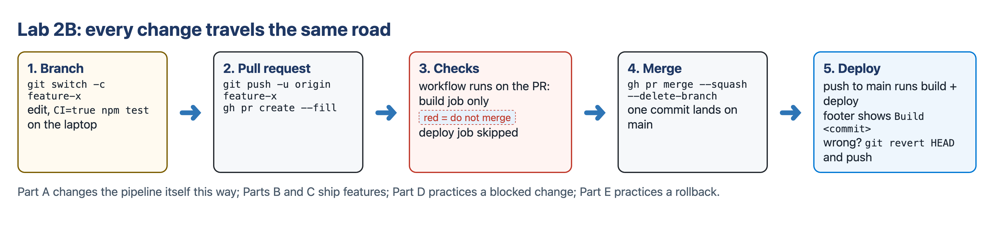
Figure 1. The road every change takes in this lab.
What the next figure shows: The heading Wasatch Front Fall Sports Schedule (you change it in Part D). Under it the Field dropdown is set to Field 1 and the count reads 3 games shown. The first card is crossed out in red and its button now says Reinstate; the other cards still say Cancel. The grey footer Build b865fcf is the first seven characters of the commit the pipeline built; yours shows your own commit.
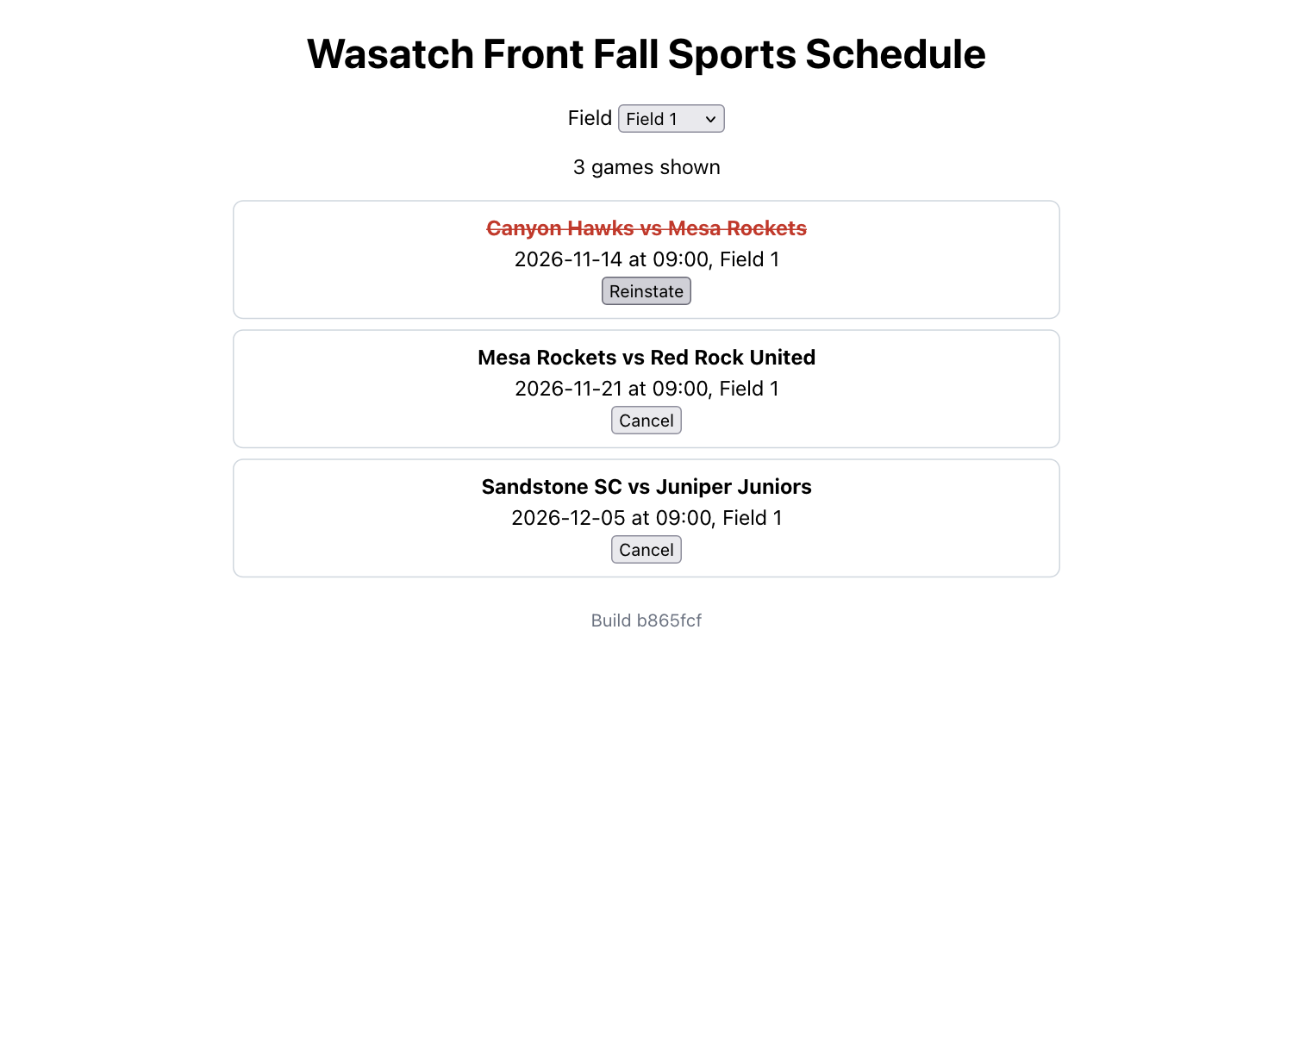
Figure 2. Where you finish: the app after Part D, with Field 1 selected and one game cancelled.

Before you start (10 min)
Mac users: the Mac Terminal runs zsh. The blocks below have no # comments and no angle-bracket placeholders, so they paste as they are. Cloud Shell and Git Bash run bash; the blocks work there too.

Set your values once per terminal
Replace yourteam with your Web App's suffix (the app is my-react-app-yourteam if you followed Lab 2), and yourgithubuser with your GitHub user name. Run the three lines in every new terminal.
Terminal in VS Code
APP=my-react-app-yourteam
GH_USER=yourgithubuser
echo "Web App: $APP repository: $GH_USER/my-react-app"

Line | What it does and what it prints
APP=my-react-app-yourteam | Stores your Web App's name. No spaces around =.
GH_USER=yourgithubuser | Stores your GitHub user name.
echo "Web App: ..." | Prints both so you can check them.

Start from the latest main
Terminal in VS Code, in the my-react-app folder
gh auth status
git switch main
git pull
ls .github/workflows
CI=true npm test

Line | What it does and what it prints
gh auth status | Confirms the GitHub CLI is signed in: Logged in to github.com account <you>. If not, run gh auth login as in Lab 2.
git switch main | Moves to the main branch: Switched to branch 'main' or Already on 'main'.
git pull | Downloads what is on GitHub, including the workflow file Azure committed in Lab 2.
ls .github/workflows | Must list exactly one file, main_ plus your app name plus .yml. If the app name in it is a different app, fix that first (Lab 2 appendix, Connected to the wrong Web App).
CI=true npm test | The Lab 2 test passes: Tests: 1 passed, 1 total. Every part of this lab starts from green.

Note
Branches and pull requests in one paragraph. A branch is a named line of commits. main is the one Azure deploys. You do each change on a new branch, push it, and open a pull request (PR), which asks to merge the branch into main. GitHub runs your workflow on the PR and shows the result as a check. You merge only when the check is green; the merge is a push to main, which deploys.

Part A. Improve the pipeline and show the live build (20 min)
The workflow Azure wrote runs only when something is pushed to main, so a mistake is found after it is already on its way to the live site. You change four things in it, and you make the page show which commit is live. You do it the way every later change is done: on a branch, through a pull request.
Terminal in VS Code
git switch -c improve-pipeline

Line | What it does and what it prints
git switch -c improve-pipeline | Creates a new branch named improve-pipeline and moves to it: Switched to a new branch 'improve-pipeline'. Your edits now stay off main until you merge them.

A1. Four edits to the workflow file
Open .github/workflows/main_<your app>.yml in VS Code. Keep your own app name and your own three secret lines exactly as they are; change only the four places below. YAML is sensitive to spaces: indent with spaces, never tabs, and line up new lines with the ones around them.
Edit 1. Run on pull requests too. Under on:, add the pull_request: lines between push: and workflow_dispatch: so the block reads:
on:
push:
branches:
- 'main'
pull_request:
branches:
- 'main'
workflow_dispatch:

Edit 2. Use the current setup-node action. Change uses: actions/setup-node@v3 to uses: actions/setup-node@v4. Version 3 runs on a Node version GitHub has retired, which is why Lab 2's run page showed a warning annotation; a workflow linter reports it as too old to run on GitHub Actions.
Edit 3. Install exactly what was tested, and stamp the build. In the npm install, build, and test step, change npm install to npm ci and add the two env: lines under the run: block, lined up with run::
- name: npm install, build, and test
run: |
npm ci
npm run build --if-present
npm run test --if-present
env:
REACT_APP_BUILD_SHA: ${{ github.sha }}

Edit 4. Never deploy a pull request. In the deploy: job, add the if: line under needs: build:
deploy:
runs-on: ubuntu-latest
needs: build
if: github.event_name != 'pull_request'

Line | What it does and what it prints
pull_request: branches: - 'main' | Runs the workflow when a pull request into main is opened or gets new commits, so the check appears on the PR page.
actions/setup-node@v4 | The supported version of the action that installs Node on the GitHub runner.
npm ci | Installs exactly the versions in package-lock.json and fails if package.json and the lock file disagree. npm install may quietly pick newer versions than the ones you tested.
REACT_APP_BUILD_SHA: ${{ github.sha }} | Gives the build the commit ID. Create React App copies any variable that starts with REACT_APP_ into the page when it builds, so the page can show it.
if: github.event_name != 'pull_request' | Skips the deploy job for pull requests. A PR is a proposal; only a merged change should reach the live site. Without this line the deploy job would also fail: Azure trusts only the main branch of your repository, and a PR sign-in is refused (see the appendix).

The whole file after the four edits, from the 2026-11-05 check. Your app name and secret names differ; everything else should match:
# Docs for the Azure Web Apps Deploy action: https://github.com/Azure/webapps-deploy
# More GitHub Actions for Azure: https://github.com/Azure/actions

name: Build and deploy Node.js app to Azure Web App - my-react-app-yourteam

on:
push:
branches:
- 'main'
pull_request:
branches:
- 'main'
workflow_dispatch:

jobs:
build:
runs-on: ubuntu-latest
permissions:
contents: read #This is required for actions/checkout

steps:
- uses: actions/checkout@v4

- name: Set up Node.js version
uses: actions/setup-node@v4
with:
node-version: '24.x'

- name: npm install, build, and test
run: |
npm ci
npm run build --if-present
npm run test --if-present
env:
REACT_APP_BUILD_SHA: ${{ github.sha }}

- name: Upload artifact for deployment job
uses: actions/upload-artifact@v4
with:
name: node-app
path: .

deploy:
runs-on: ubuntu-latest
needs: build
if: github.event_name != 'pull_request'
permissions:
id-token: write #This is required for requesting the JWT
contents: read #This is required for actions/checkout

steps:
- name: Download artifact from build job
uses: actions/download-artifact@v4
with:
name: node-app

- name: Login to Azure
uses: azure/login@v2
with:
client-id: ${{ secrets.AZUREAPPSERVICE_CLIENTID_XXXX }}
tenant-id: ${{ secrets.AZUREAPPSERVICE_TENANTID_XXXX }}
subscription-id: ${{ secrets.AZUREAPPSERVICE_SUBSCRIPTIONID_XXXX }}

- name: 'Deploy to Azure Web App'
id: deploy-to-webapp
uses: azure/webapps-deploy@v3
with:
app-name: 'my-react-app-yourteam'
slot-name: 'Production'
package: .

A2. Show the build on the page
Replace the whole of src/App.js:
src/App.js
import './App.css';

const BUILD = (process.env.REACT_APP_BUILD_SHA || 'local').slice(0, 7);

function App() {
return (
<div className="App">
<h1>Hello from React deployed with Azure CI/CD!</h1>
<footer className="build">Build {BUILD}</footer>
</div>
);
}

export default App;

Line | What it does and what it prints
process.env.REACT_APP_BUILD_SHA | The commit ID the workflow passed in Edit 3. On your laptop it is not set.
|| 'local' | Uses the word local when the variable is not set, so the page still works when you run it yourself.
.slice(0, 7) | Keeps the first seven characters, the short commit ID Git and GitHub show.
<footer className="build">Build {BUILD}</footer> | Curly braces put a JavaScript value into the page.

Add a test for the footer. Replace the whole of src/App.test.js:
src/App.test.js
import { render, screen } from '@testing-library/react';
import App from './App';

test('renders the Azure CI/CD heading', () => {
render(<App />);
const heading = screen.getByText(/hello from react deployed with azure ci\/cd/i);
expect(heading).toBeInTheDocument();
});

test('shows the build stamp', () => {
render(<App />);
expect(screen.getByText(/build local/i)).toBeInTheDocument();
});

Terminal in VS Code
CI=true npm test
CI=true npm run build

Expected result
Tests: 2 passed, 2 total (renders the Azure CI/CD heading, shows the build stamp) and Compiled successfully.

A3. Open the pull request, watch the check, merge
Terminal in VS Code
git add .
git commit -m "Pipeline: pull request checks, npm ci, build stamp, setup-node v4"
git push -u origin improve-pipeline
gh pr create --fill
gh pr checks --watch

Line | What it does and what it prints
git add . and git commit -m "..." | Records the workflow and the two app files as one commit on the branch: [improve-pipeline a5c13d9] Pipeline: ..., 3 files changed (your ID differs).
git push -u origin improve-pipeline | Sends the branch to GitHub and remembers it: the last lines are * [new branch] improve-pipeline -> improve-pipeline and branch 'improve-pipeline' set up to track 'origin/improve-pipeline'.
gh pr create --fill | Opens a pull request from this branch into main, using the commit message as the title. It prints the PR address, ending in /pull/1.
gh pr checks --watch | Follows the checks until they finish. Expect the build check to pass and deploy to be listed as skipped. Press Ctrl+C to stop watching early.

Console: where to click
Open the PR on GitHub (gh pr view --web). The Conversation tab shows the checks box: build with a green check, deploy skipped. The Files changed tab shows your edits line by line in green (added) and red (removed): read them once, as a reviewer would.
Have a teammate review: Files changed → Review changes → Approve (optional, but it is how teams work).

Terminal in VS Code
gh pr merge --squash --delete-branch
git pull
sleep 15
RUN=$(gh run list --branch main --limit 1 --json databaseId --jq '.[0].databaseId')
gh run watch "$RUN" --exit-status

Line | What it does and what it prints
gh pr merge --squash --delete-branch | Merges the PR as one commit on main, deletes the branch on GitHub and on your laptop, and switches you back to main.
git pull | Brings the merge commit to your laptop.
sleep 15 | Waits 15 seconds so GitHub has started the run for the merge before the next line looks for it.
RUN=$(gh run list --branch main ...) | Finds the newest pipeline run on main (the one the merge started) and stores its number.
gh run watch "$RUN" --exit-status | Follows that run: this time both build and deploy run. It ends with a success line, or an error if a job failed.

A4. Prove which commit is live
Terminal in VS Code
git rev-parse --short HEAD
open "https://$APP.azurewebsites.net"

Line | What it does and what it prints
git rev-parse --short HEAD | Prints the short ID of the commit you are on, for example b865fcf.
open "https://$APP.azurewebsites.net" | Opens your site (Windows: start, Linux: xdg-open, or paste the address). The footer must say Build followed by the same seven characters. If it says local or an older ID, the deploy is still running or Edit 3 is missing.

Expected result
A green PR with a skipped deploy, a green run on main with build and deploy, and the live footer showing the commit you just merged. Screenshot 1: the live page with the footer and the address bar.

Part B. Load and list the schedule (20 min)
A real app shows data. You add a schedule file, a component that draws one game, and code that loads the file when the page opens. React ideas: components, props, state, effects and lists with keys.
Terminal in VS Code
git switch -c feature-schedule

B1. The data file
Create public/schedule.json (right-click the public folder → New File). Files in public are copied to the site as they are, so the browser can download this one at /schedule.json. Paste:
[
{ "id": 1, "date": "2026-11-14", "time": "09:00", "field": "Field 1", "home": "Canyon Hawks", "away": "Mesa Rockets", "cancelled": false },
{ "id": 2, "date": "2026-11-14", "time": "10:30", "field": "Field 2", "home": "Red Rock United", "away": "Flat Iron FC", "cancelled": false },
{ "id": 3, "date": "2026-11-14", "time": "12:00", "field": "Field 3", "home": "Juniper Juniors", "away": "Sandstone SC", "cancelled": true },
{ "id": 4, "date": "2026-11-21", "time": "09:00", "field": "Field 1", "home": "Mesa Rockets", "away": "Red Rock United", "cancelled": false },
{ "id": 5, "date": "2026-11-21", "time": "10:30", "field": "Field 2", "home": "Flat Iron FC", "away": "Canyon Hawks", "cancelled": false },
{ "id": 6, "date": "2026-12-05", "time": "09:00", "field": "Field 1", "home": "Sandstone SC", "away": "Juniper Juniors", "cancelled": false }
]

B2. A component for one game
Create src/GameCard.js:
src/GameCard.js
function GameCard({ game }) {
return (
<li className="game">
<strong>{game.home} vs {game.away}</strong>
<span>{game.date} at {game.time}, {game.field}</span>
</li>
);
}

export default GameCard;

Line | What it does and what it prints
function GameCard({ game }) | A component is a function that returns what to draw. { game } takes the prop named game that the parent passes in.
<li className="game"> | One list item, styled by the game class you add to the CSS below.
{game.home} vs {game.away} | Reads fields of the game object. The same component draws every game; only the props differ.
export default GameCard; | Lets App.js import it.

B3. Load the file and draw the list
Replace the whole of src/App.js:
src/App.js
import { useEffect, useState } from 'react';
import './App.css';
import GameCard from './GameCard';

const BUILD = (process.env.REACT_APP_BUILD_SHA || 'local').slice(0, 7);

function App() {
const [games, setGames] = useState([]);
const [status, setStatus] = useState('loading');

useEffect(() => {
fetch('/schedule.json')
.then((response) => response.json())
.then((data) => {
setGames(data);
setStatus('ready');
})
.catch(() => setStatus('error'));
}, []);

return (
<div className="App">
<h1>Hello from React deployed with Azure CI/CD!</h1>
{status === 'loading' && <p>Loading the schedule...</p>}
{status === 'error' && <p>Could not load the schedule.</p>}
<ul className="games">
{games.map((game) => (
<GameCard key={game.id} game={game} />
))}
</ul>
<footer className="build">Build {BUILD}</footer>
</div>
);
}

export default App;

Line | What it does and what it prints
const [games, setGames] = useState([]); | State: a value React remembers between redraws. It starts as an empty list; calling setGames with new data redraws the page.
const [status, setStatus] = useState('loading'); | A second piece of state: loading, ready or error.
useEffect(() => { ... }, []); | Runs code after the first draw. The empty [] means only once, when the page opens.
fetch('/schedule.json') | Downloads the data file from the same site.
.then((data) => { setGames(data); setStatus('ready'); }) | When the file arrives, store the games and mark the status ready. React redraws with the list.
{status === 'loading' && <p>...</p>} | Conditional rendering: the paragraph appears only while loading.
games.map((game) => <GameCard key={game.id} game={game} />) | Turns each game into a card. key must be unique so React can tell the cards apart when the list changes.

Add the styles: open src/App.css and paste this at the end of the file (keep what is there):

.games {
list-style: none;
padding: 0;
max-width: 640px;
margin: 0 auto;
}

.game {
display: flex;
flex-direction: column;
gap: 4px;
border: 1px solid #d0d7de;
border-radius: 8px;
padding: 10px;
margin: 8px 0;
}

.game button {
align-self: center;
}

.game.cancelled strong {
text-decoration: line-through;
color: #c0392b;
}

.build {
margin-top: 24px;
color: #6b7280;
font-size: 0.85rem;
}

B4. Test it
The test now runs without a browser and without a server, so it gives the app a pretend fetch that returns two games. Replace the whole of src/App.test.js:
src/App.test.js
import { render, screen } from '@testing-library/react';
import App from './App';

const sample = [
{ id: 1, date: '2026-11-14', time: '09:00', field: 'Field 1', home: 'Canyon Hawks', away: 'Mesa Rockets', cancelled: false },
{ id: 2, date: '2026-11-14', time: '10:30', field: 'Field 2', home: 'Red Rock United', away: 'Flat Iron FC', cancelled: false },
];

beforeEach(() => {
global.fetch = jest.fn(() => Promise.resolve({ json: () => Promise.resolve(sample) }));
});

test('renders the Azure CI/CD heading', async () => {
render(<App />);
expect(screen.getByText(/hello from react deployed with azure ci\/cd/i)).toBeInTheDocument();
await screen.findByText('Canyon Hawks vs Mesa Rockets');
});

test('shows one card per game in schedule.json', async () => {
render(<App />);
expect(await screen.findByText('Canyon Hawks vs Mesa Rockets')).toBeInTheDocument();
expect(screen.getAllByRole('listitem')).toHaveLength(2);
});

test('shows the build stamp', async () => {
render(<App />);
expect(screen.getByText(/build local/i)).toBeInTheDocument();
await screen.findByText('Canyon Hawks vs Mesa Rockets');
});

Line | What it does and what it prints
const sample = [ ... ]; | Two games used only by the tests.
global.fetch = jest.fn(() => Promise.resolve({ json: ... })) | Replaces fetch during the tests with a function that returns the sample. This is a mock: tests stay fast and do not depend on the network.
await screen.findByText('Canyon Hawks vs Mesa Rockets') | findBy... waits until the text appears, because the data arrives a moment after the first draw.
getAllByRole('listitem') ... toHaveLength(2) | Exactly one card per game.

Terminal in VS Code
CI=true npm test
CI=true npm run build
npm start

Expected result
Tests: 3 passed, 3 total, Compiled successfully., and in the browser at localhost:3000 six cards under the heading with the footer Build local. Stop npm start with Ctrl+C.

What the next figure shows: Six cards in date order, each with the two teams in bold and a line with the date, time and field. In Part B the dropdown, the count and the Cancel buttons are not there yet; they come in Part C. The footer shows the build stamp from Part A.
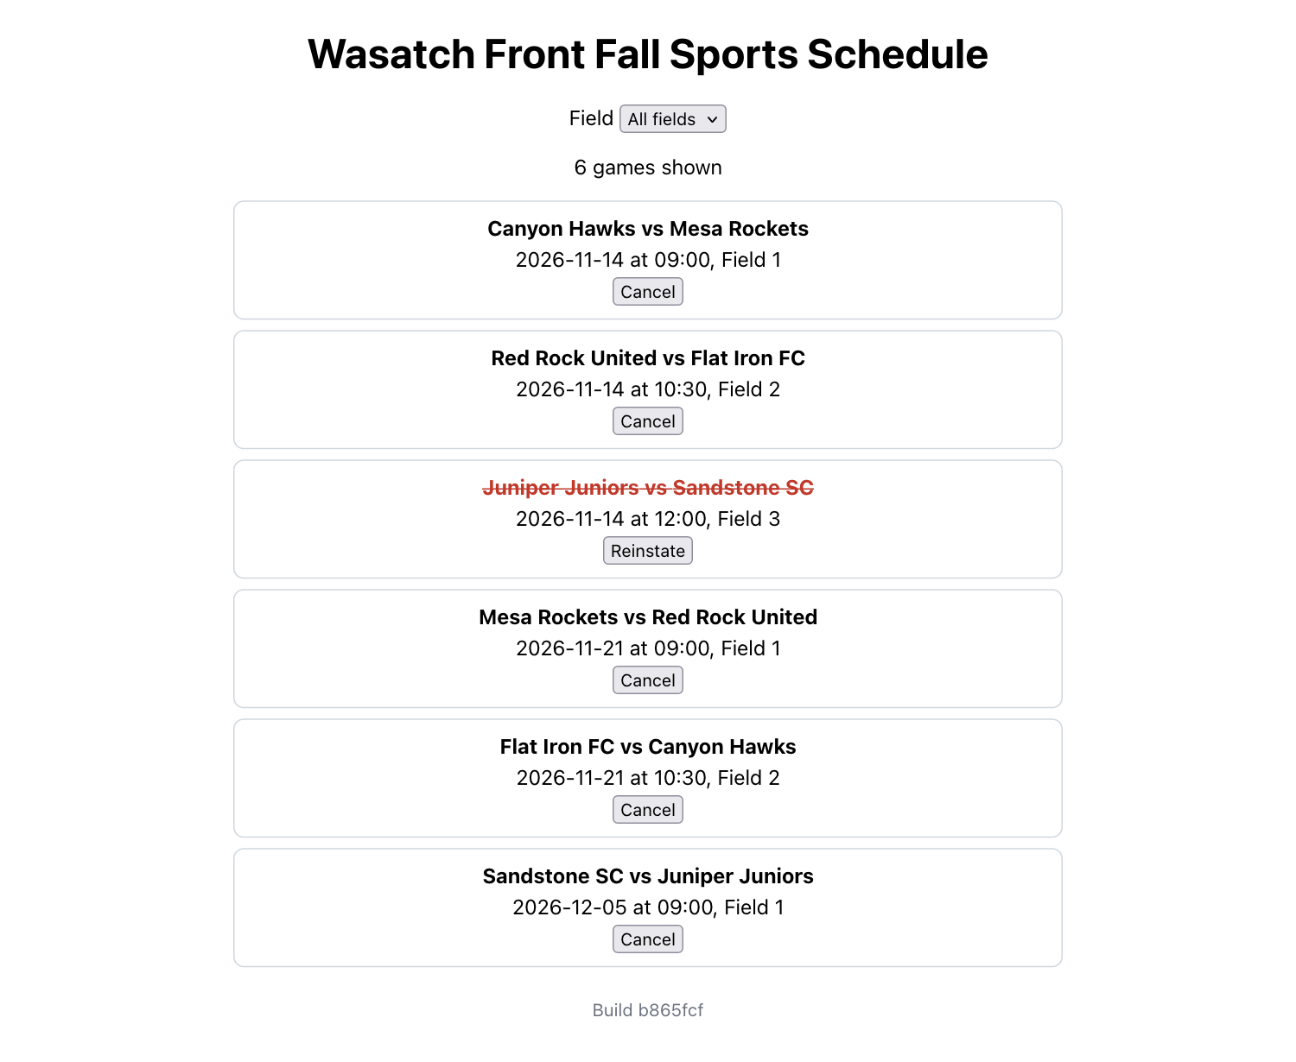
Figure 3. The schedule list (shown after Part D, so the heading already reads Wasatch Front).

B5. Ship it through a pull request
Terminal in VS Code
git add .
git commit -m "Schedule: load schedule.json and list the games"
git push -u origin feature-schedule
gh pr create --fill
gh pr checks --watch
gh pr merge --squash --delete-branch
git pull

Expected result
The PR check passes, the merge starts a run on main with build and deploy, and the live site lists the six games with a new commit ID in the footer. Screenshot 2: the green check on the PR's Conversation tab.

Part C. Filter by field and cancel a game (20 min)
Now the page reacts to the user. React ideas: controlled inputs, events, passing a function down as a prop, and derived data.
Terminal in VS Code
git switch -c feature-filter

Replace the whole of src/GameCard.js:
src/GameCard.js
function GameCard({ game, onToggle }) {
return (
<li className={game.cancelled ? 'game cancelled' : 'game'}>
<strong>{game.home} vs {game.away}</strong>
<span>{game.date} at {game.time}, {game.field}</span>
<button onClick={() => onToggle(game.id)}>
{game.cancelled ? 'Reinstate' : 'Cancel'}
</button>
</li>
);
}

export default GameCard;

Replace the whole of src/App.js:
src/App.js
import { useEffect, useState } from 'react';
import './App.css';
import GameCard from './GameCard';

const BUILD = (process.env.REACT_APP_BUILD_SHA || 'local').slice(0, 7);

function App() {
const [games, setGames] = useState([]);
const [status, setStatus] = useState('loading');
const [field, setField] = useState('All fields');

useEffect(() => {
fetch('/schedule.json')
.then((response) => response.json())
.then((data) => {
setGames(data);
setStatus('ready');
})
.catch(() => setStatus('error'));
}, []);

const toggleGame = (id) =>
setGames(games.map((g) => (g.id === id ? { ...g, cancelled: !g.cancelled } : g)));

const visible = games.filter((g) => field === 'All fields' || g.field === field);

return (
<div className="App">
<h1>Hello from React deployed with Azure CI/CD!</h1>
{status === 'loading' && <p>Loading the schedule...</p>}
{status === 'error' && <p>Could not load the schedule.</p>}
<label>
Field{' '}
<select value={field} onChange={(e) => setField(e.target.value)}>
<option>All fields</option>
<option>Field 1</option>
<option>Field 2</option>
<option>Field 3</option>
</select>
</label>
<p>{visible.length} {visible.length === 1 ? 'game' : 'games'} shown</p>
<ul className="games">
{visible.map((game) => (
<GameCard key={game.id} game={game} onToggle={toggleGame} />
))}
</ul>
<footer className="build">Build {BUILD}</footer>
</div>
);
}

export default App;

Line | What it does and what it prints
const [field, setField] = useState('All fields'); | State for the dropdown's choice.
<select value={field} onChange={(e) => setField(e.target.value)}> | A controlled input: the dropdown shows what is in state, and every change updates state. React then redraws.
const visible = games.filter(...) | Derived data: the cards to show are computed from games and field on every draw, not stored separately.
{visible.length === 1 ? 'game' : 'games'} | A small condition so the count reads 1 game shown and 3 games shown.
const toggleGame = (id) => setGames(games.map(...)) | Makes a new list in which only the clicked game's cancelled flag is flipped. React state is replaced, never edited in place.
<GameCard ... onToggle={toggleGame} /> | Passes the function down as a prop. The card calls it; App owns the data. This is called lifting state up.
In GameCard: onClick={() => onToggle(game.id)} | The click event calls the parent's function with this game's ID.
In GameCard: className={game.cancelled ? 'game cancelled' : 'game'} | Adds the cancelled style, which crosses the teams out in red.

Replace the whole of src/App.test.js (the first three tests are unchanged; two are new, and fireEvent is added to the first line):
src/App.test.js
import { render, screen, fireEvent } from '@testing-library/react';
import App from './App';

const sample = [
{ id: 1, date: '2026-11-14', time: '09:00', field: 'Field 1', home: 'Canyon Hawks', away: 'Mesa Rockets', cancelled: false },
{ id: 2, date: '2026-11-14', time: '10:30', field: 'Field 2', home: 'Red Rock United', away: 'Flat Iron FC', cancelled: false },
];

beforeEach(() => {
global.fetch = jest.fn(() => Promise.resolve({ json: () => Promise.resolve(sample) }));
});

test('renders the Azure CI/CD heading', async () => {
render(<App />);
expect(screen.getByText(/hello from react deployed with azure ci\/cd/i)).toBeInTheDocument();
await screen.findByText('Canyon Hawks vs Mesa Rockets');
});

test('shows one card per game in schedule.json', async () => {
render(<App />);
expect(await screen.findByText('Canyon Hawks vs Mesa Rockets')).toBeInTheDocument();
expect(screen.getAllByRole('listitem')).toHaveLength(2);
});

test('shows the build stamp', async () => {
render(<App />);
expect(screen.getByText(/build local/i)).toBeInTheDocument();
await screen.findByText('Canyon Hawks vs Mesa Rockets');
});

test('filters the list by field', async () => {
render(<App />);
await screen.findByText('Canyon Hawks vs Mesa Rockets');
fireEvent.change(screen.getByRole('combobox'), { target: { value: 'Field 2' } });
expect(screen.getByText('1 game shown')).toBeInTheDocument();
expect(screen.queryByText('Canyon Hawks vs Mesa Rockets')).not.toBeInTheDocument();
});

test('cancels a game and can reinstate it', async () => {
render(<App />);
await screen.findByText('Canyon Hawks vs Mesa Rockets');
fireEvent.click(screen.getAllByText('Cancel')[0]);
expect(screen.getByText('Reinstate')).toBeInTheDocument();
fireEvent.click(screen.getByText('Reinstate'));
expect(screen.getAllByText('Cancel')).toHaveLength(2);
});

Line | What it does and what it prints
fireEvent.change(screen.getByRole('combobox'), { target: { value: 'Field 2' } }) | Chooses Field 2 in the dropdown, as a user would.
expect(screen.getByText('1 game shown')) | Only one of the two sample games is on Field 2.
fireEvent.click(screen.getAllByText('Cancel')[0]) | Clicks the first Cancel button; the test then expects a Reinstate button and, after clicking it, two Cancel buttons again.

Terminal in VS Code
CI=true npm test
CI=true npm run build

Expected result
Tests: 5 passed, 5 total and Compiled successfully. Run npm start and try it: choose Field 1 (3 games shown), cancel a game, reinstate it.

Terminal in VS Code
git add .
git commit -m "Schedule: filter by field, cancel and reinstate games"
git push -u origin feature-filter
gh pr create --fill
gh pr checks --watch
gh pr merge --squash --delete-branch
git pull

Expected result
Green check, merge, deploy; on the live site the dropdown filters and the buttons work. Screenshot 3: the live page with a field selected and one game cancelled.

Part D. A red check blocks the merge (10 min)
The league renamed itself. A teammate changes the heading but forgets the test that checks it. Watch the pipeline catch it before it reaches the live site.
Terminal in VS Code
git switch -c rename-heading

In src/App.js, change only the heading line to <h1>Wasatch Front Fall Sports Schedule</h1>. Do not change the test. Save, then:
Terminal in VS Code
git add .
git commit -m "Rename the heading"
git push -u origin rename-heading
gh pr create --fill
gh pr checks --watch

Expected result
gh pr checks reports the build check as failed (fail) and ends with an error. On the PR page the checks box is red and says the checks were not successful. Nothing deployed: the live site still shows the old heading and the old build ID.

Read why it failed, from the terminal:
Terminal in VS Code
RUN=$(gh run list --branch rename-heading --limit 1 --json databaseId --jq '.[0].databaseId')
gh run view "$RUN" --log-failed

Line | What it does and what it prints
RUN=$(gh run list --branch rename-heading ...) | The newest run for this branch.
gh run view "$RUN" --log-failed | Prints only the log lines of the step that failed: the same test output you would see locally, shown in the next figure.

What the next figure shows: Four tests pass and one fails: renders the Azure CI/CD heading. The red error says the test could not find an element with the text /hello from react deployed with azure ci\/cd/i, because the page now says Wasatch Front. The last line is the summary: 1 failed, 4 passed, 5 total. Because the test step failed, the build check failed, and a failed check is the signal not to merge.
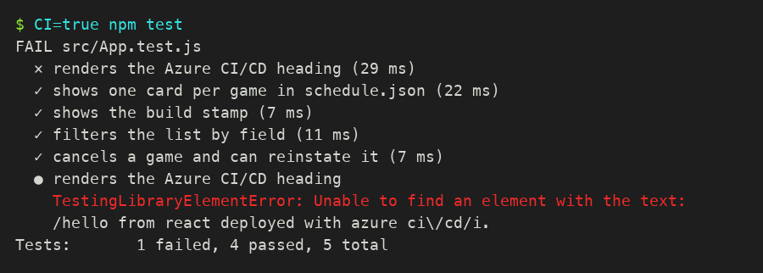
Figure 4. The failing test, as CI=true npm test prints it (the run log shows the same lines).
Fix the test, not the pipeline. In src/App.test.js, change the first test to look for the new heading. The fixed test, from the 2026-11-05 run:
test('renders the schedule heading', async () => {
render(<App />);
expect(screen.getByText(/wasatch front fall sports schedule/i)).toBeInTheDocument();
await screen.findByText('Canyon Hawks vs Mesa Rockets');
});

Terminal in VS Code
CI=true npm test
git add .
git commit -m "Test the new heading"
git push
gh pr checks --watch
gh pr merge --squash --delete-branch
git pull

Line | What it does and what it prints
git push | The branch already tracks GitHub, so a plain push adds the fix to the same PR, and the checks run again.
gh pr checks --watch | Now green. Merge as before; the live heading changes.

What the next figure shows: Tests: 5 passed, 5 total with the first test now named renders the schedule heading, and Compiled successfully. for the production build. This is what the PR's build check runs.
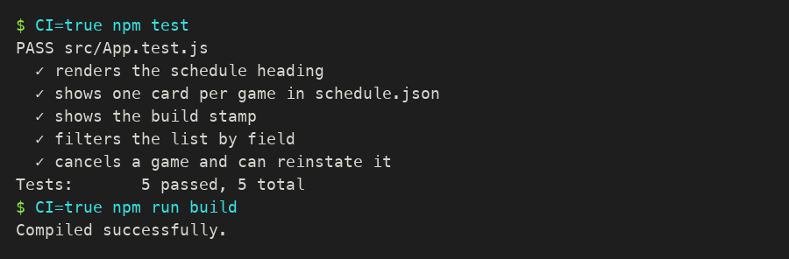
Figure 5. All five tests and the build after the fix.
Expected result
Screenshot 4: the PR page with the red check and, below it, the green check after your fix (scroll the Conversation tab; both runs are listed).

Part E. A bad change gets through: roll back (10 min)
Tests check code, not data. Someone pushes a schedule with a typo straight to main (do this only because the lab asks you to). It passes the tests, deploys, and the live site is wrong. You restore the last good version with git revert, which adds a new commit that undoes the bad one, and time how long the site takes to recover.
Terminal in VS Code: the bad change
echo '[{"id":9,"date":"2026-11-15","time":"25:00","field":"Field 9","home":"Typo FC","away":"Oops United","cancelled":false}]' > public/schedule.json
git commit -am "Update schedule"
git push origin main

Line | What it does and what it prints
echo '[...]' > public/schedule.json | Overwrites the schedule with one wrong game (25:00, Field 9). The single quotes keep zsh from touching the text.
git commit -am "Update schedule" | -a commits every changed file that Git already tracks, so no git add is needed.
git push origin main | Goes straight to main: build, tests (they pass, because they use their own sample data) and deploy.

Wait for the run (gh run watch as in Part A), reload the live site: it lists only Typo FC vs Oops United. Now roll back and note the clock time:
Terminal in VS Code: the rollback
date
git revert HEAD --no-edit
git push origin main
git log --oneline -3

What the next figure shows: git revert HEAD --no-edit made a new commit Revert "Update schedule" that puts the old file back (1 file changed, 8 insertions(+), 1 deletion(-)). The push sent it to main, and git log --oneline -3 shows the history in order: the revert on top, the bad commit under it, and the good pipeline commit below. Nothing was deleted; the mistake and its fix are both on record.
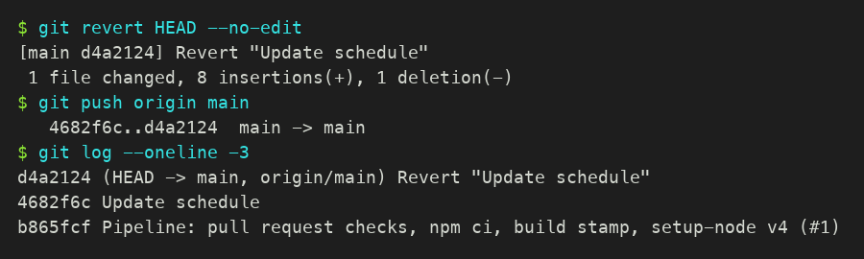
Figure 6. The revert from the 2026-11-05 run.
Line | What it does and what it prints
date | Your stopwatch start.
git revert HEAD --no-edit | Creates a commit that undoes the last one. --no-edit keeps Git's message Revert "Update schedule" instead of opening an editor.
git push origin main | Starts the pipeline again; it deploys the restored schedule.
git log --oneline -3 | The last three commits, newest first.

Watch the run, reload the site until the six games are back and the footer shows the revert's commit ID (git rev-parse --short HEAD), then run date again. The difference is your time to restore, one of the four DORA measures of a delivery team.
Expected result
The live site lists the six games again. Write down the two times. Screenshot 5: the Actions tab with the bad run and the revert run, both green (green does not mean right).

Part F. Verify and submit (5 min)
Check | Command | Expected
Four PRs, three merged after green checks | gh pr list --state all --limit 5 | improve-pipeline, feature-schedule, feature-filter, rename-heading, all MERGED
Runs on main deployed | gh run list --branch main --limit 6 | completed, success
The live build is your newest commit | git rev-parse --short HEAD, then the site footer | the same seven characters
Tests on your laptop | CI=true npm test | Tests: 5 passed, 5 total
The live data file | curl -s "https://$APP.azurewebsites.net/schedule.json" | head -c 120 | the start of the six-game schedule

What to submit
- Your live URL.
- Screenshots 1 to 5 from Parts A to E.
- The link to the PR from Part D (red, then green).
- Your time to restore from Part E (start and end times).
- Three to four sentences: what the PR check caught, what it could not catch, and who did what in your team.

Stretch, for teams that finish early
- Make the check required. Repository Settings → Rules → Rulesets → New ruleset → New branch ruleset. Name main protection, Enforcement status Active, Target branches Add target → Include default branch. Tick Require a pull request before merging and Require status checks to pass, add the check named build, then Create. Now even a direct git push origin main like Part E is refused.
- Remember changes after a reload. Save the games in the browser with localStorage in a custom hook (useLocalStorage), as in the class demo app.
- Add a search box that filters by team name, with a test that types a name and counts the cards.

Appendix. Troubleshooting
Symptom | Cause | Fix
PR check: npm ci fails, package.json and package-lock.json are not in sync | A package was added with npm install but the lock file was not committed | Run npm install locally, commit package-lock.json, push
PR: deploy job fails at Login to Azure with No matching federated identity record | Edit 4 is missing, so the PR tried to deploy; Azure trusts only pushes to main | Add if: github.event_name != 'pull_request' to the deploy job
Workflow does not run on the PR at all | Edit 1 missing or mis-indented (a YAML error shows on the Actions tab) | Compare with the full file in A1; spaces, not tabs
Footer says Build local on the live site | Edit 3 missing, or the deploy has not finished | Check the env: lines; wait for the run on main
Live page: Could not load the schedule. | schedule.json is not in public/, or is not valid JSON | Move it to public/; check commas and brackets
Test: fetch is not defined or the list never appears | The test file lost the beforeEach mock | Use the full test file from the part you are on
gh pr create: must first push the current branch | The branch is not on GitHub yet | git push -u origin <branch> first
gh pr merge: Pull request is not mergeable | A required check failed, or main changed | Fix the check; or git pull origin main, push, wait for green
Build fails on GitHub only: Treating warnings as errors because process.env.CI = true | An unused import or variable | Run CI=true npm run build locally and remove what it names

